Territorial Approach to Climate Change in the Metropolitan Region of Uruguay
Progress report: Oct 2011

Abstract: UNDP provides support to the three departments of the Metropolitan Region of Uruguay and several national institutions in developing its first Integrated Territorial Climate Plan. The Region comprises the departments of Montevideo (capital city), Canelones and San José, where almost two thirds of the national population live. The Territorial Approach to Climate Change pilot project aims to support capacity building of national and regional authorities and other key stakeholders in order to integrate climate change into territorial planning and programming, thereby developing a sub-national level Low Emissions Climate Change Resilience Development Strategy (LECRDS). The purpose of the project is also to identify risks and opportunities related to climate change, collectively building appropriate responses and accessing different sources of financing for climate change.

Funds: Basque Government USD 40.000, ART-GOLD Trust Fund USD 400.000 and Province of Québec USD 250.000

Executing Agency: UNDP

Partners: Government of Canelones, Government of Montevideo, Government of San José, Planning and Budget Office, Ministry of Environment, Ministry of Agriculture, Ministry of Energy, Ministry of Tourism, National Climate Change Response System, National Emergency System, University of the Republic, national Institute for Agriculture Research.

Status: Under implementation (September 2009 – December 2012)

Summary of results: The project started in the three departments of Montevideo, San Jose and Canelones, in the second semester of 2009. The TACC project in Uruguay is well advanced in the fourth step of the establishment of a sub-national LECDRS. Inter-institutional arrangements and local working groups have been created. GHG emissions inventory, impact maps and downscaled climate modeling have been developed. Participatory identification and prioritization of adaptation and mitigation options is finished. Cost-benefit analysis is underway. Two adaptation and local development projects have been designed: one currently under implementation (EU funds, EUR 330.000) and another project proposal for early actions to access additional sources of funding has been pre-selected (EU funds, EUR 275.000). The establishment of the LECDRS is expected to be completed by 2012 subject to the availability of funds.

Main activities to date:

Step 1: Develop a multi-stakeholders planning process
The project started with the signature of a Memorandum of Understanding signed by the three sub-national level Governments and four Ministries, which provide an inter-institutional framework from its outset. The establishment and consolidation of the multi-stakeholders working groups for each local government took place during the first two years of the project. In particular, the Coordination Climate Change Committee for Montevideo was formalized by a resolution from the government in September 2010. Representative from 6 key directorates were officially assigned by the Governor to participate and lead this committee to support the establishment of the local LECDRS. At the local level, key representatives from private sector and civil society were also engaged in the the multi-stakeholders planning process, such as rural associations, transport and energy companies, environmental and social NGOs, and research institutions focused on climate, energy and agriculture. Almost 30 workshops have been successfully completed during 2010 for diagnosis, capacity-building, identification and prioritization of actions, involving the participation of 700 experts and representatives. The working groups have identified strategic lines, specific actions and projects to be included in the work plans.

Participatory workshops:
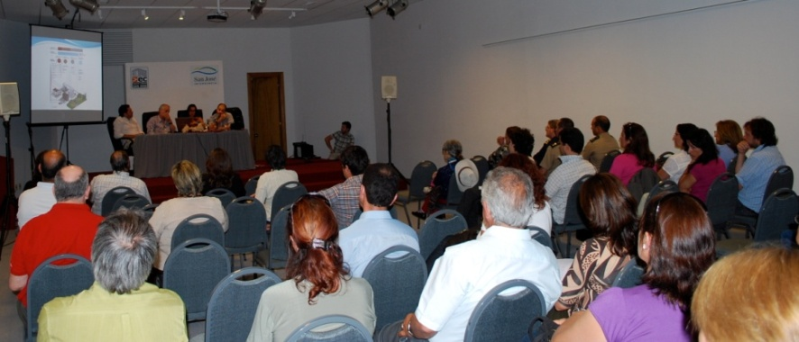
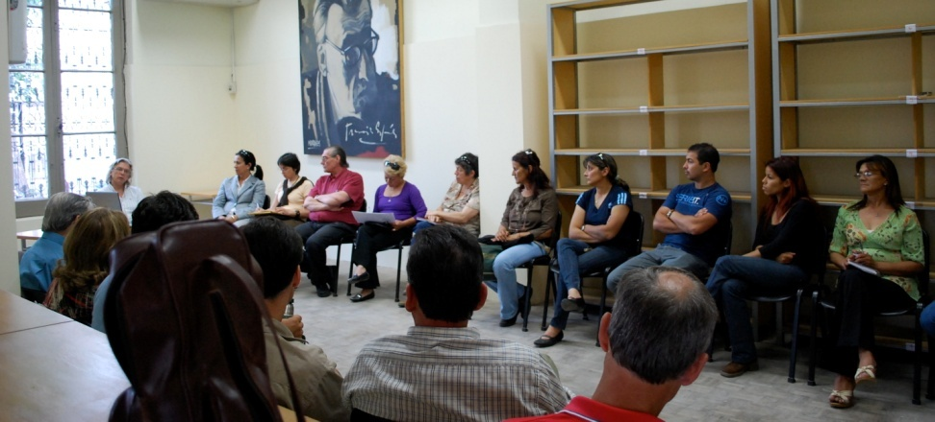
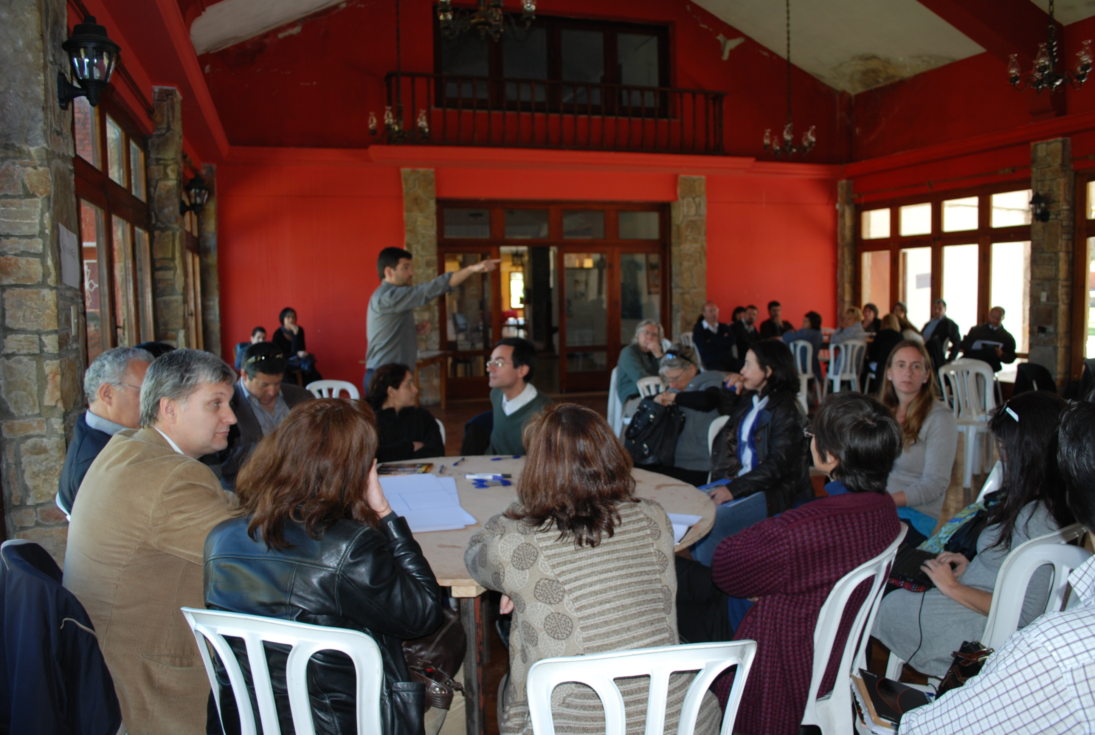
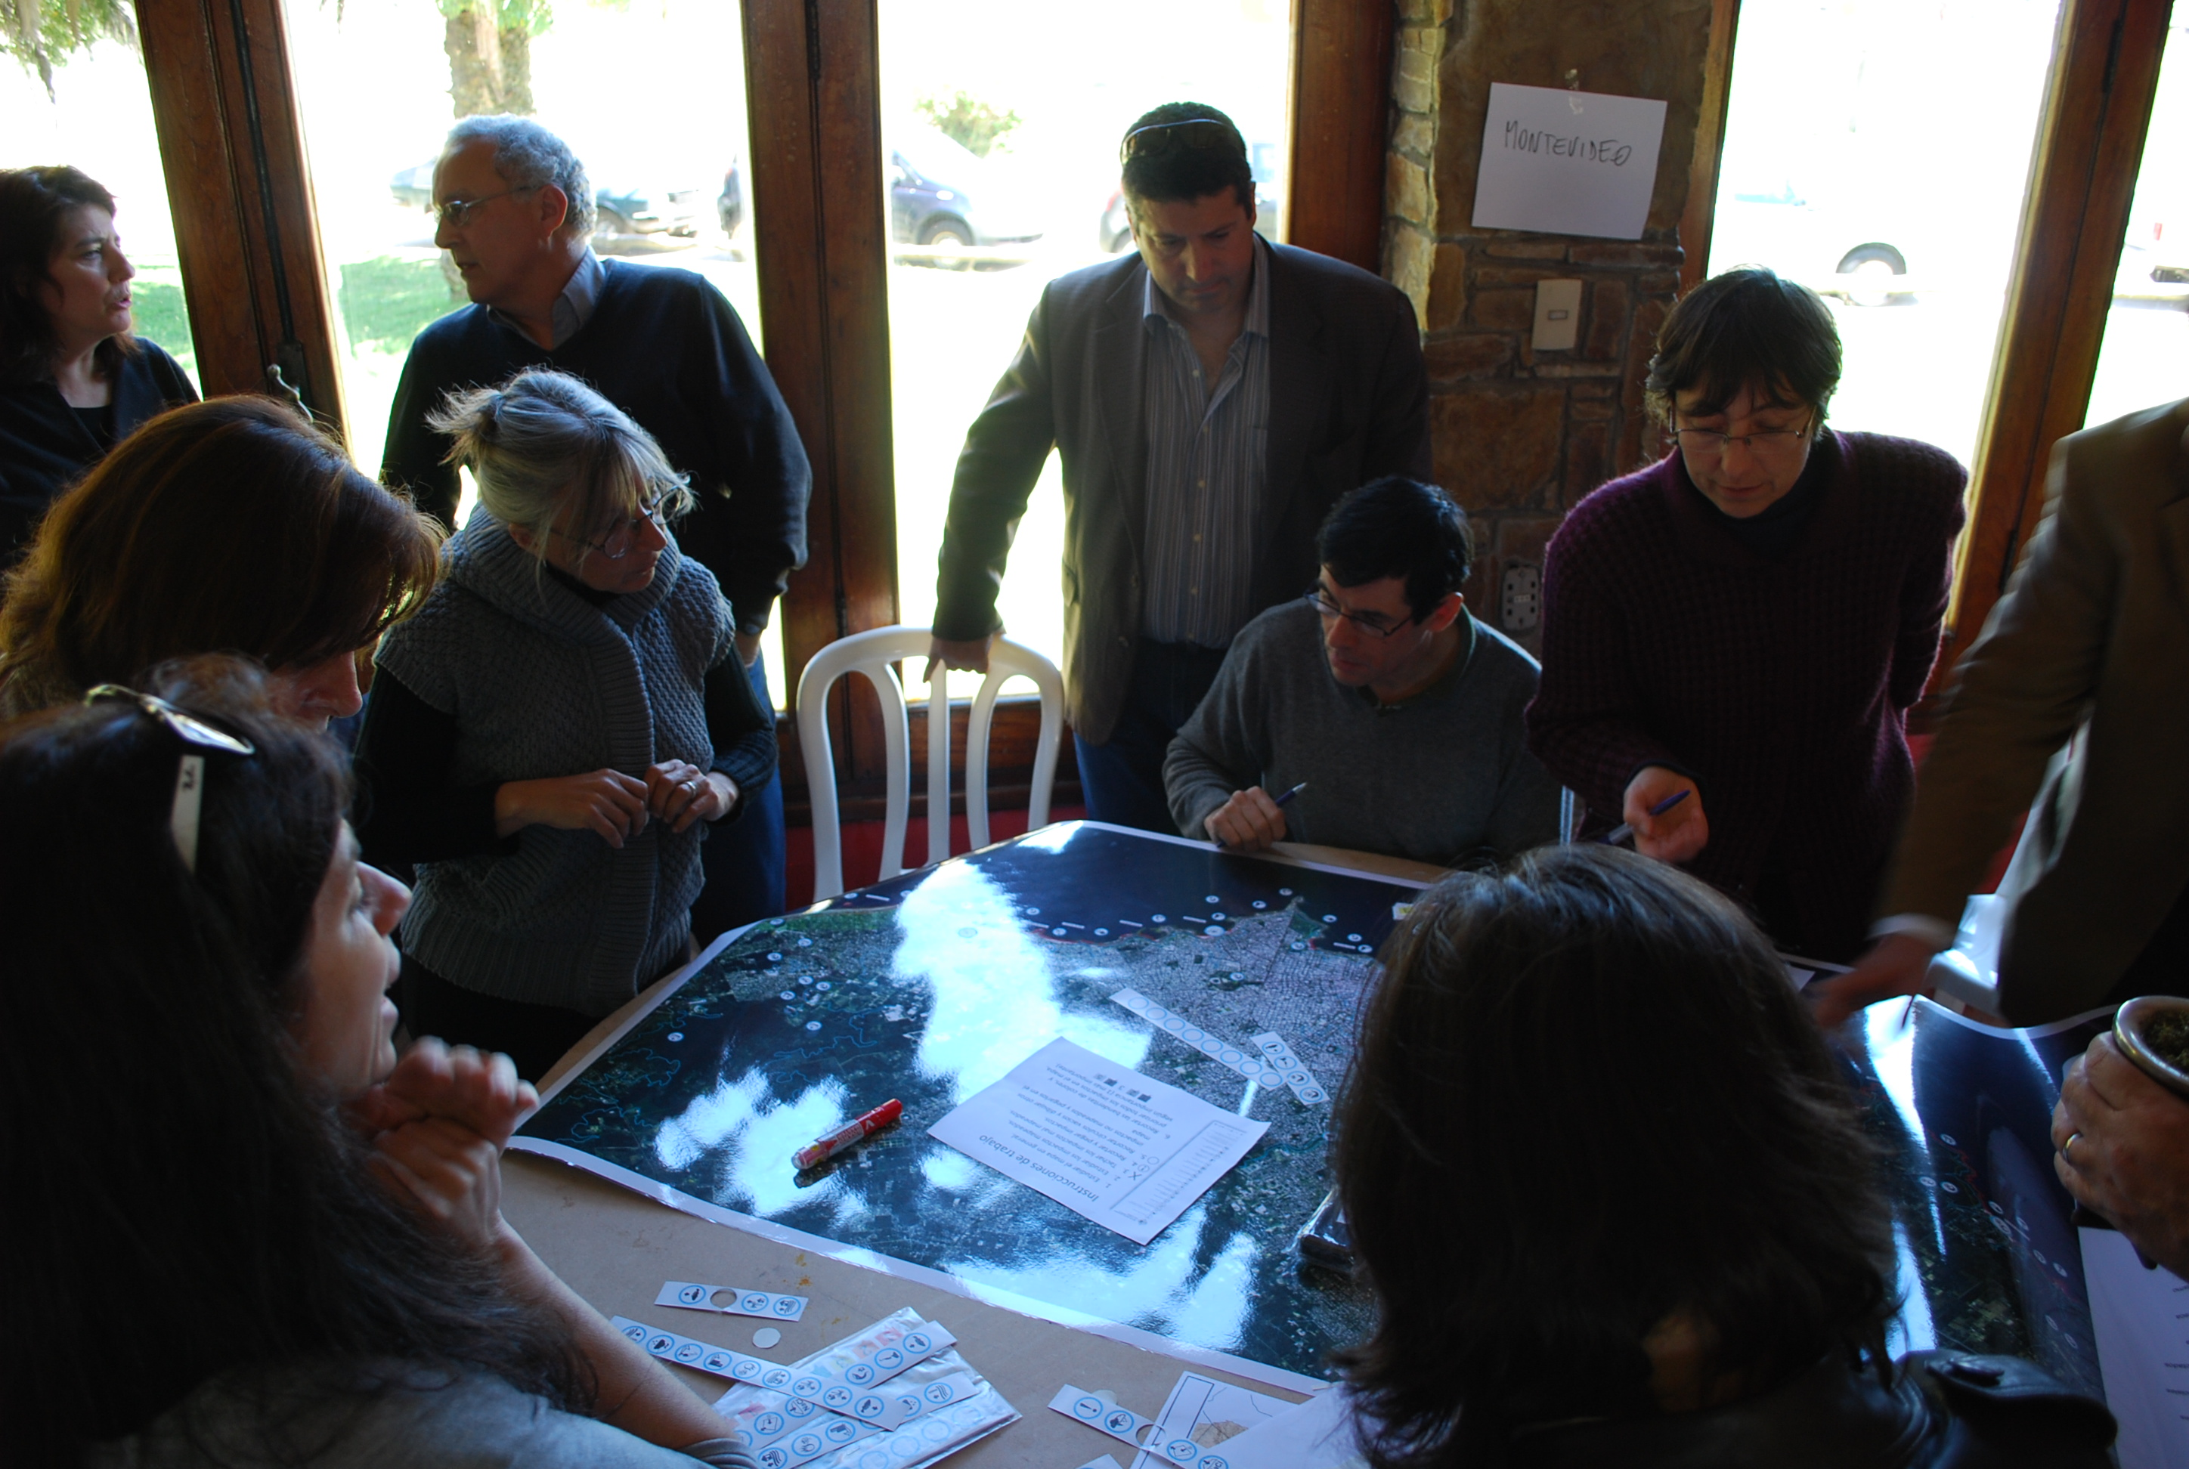

Step 2: Prepare Climate Change Profiles and Vulnerability Scenarios.
The development of the metropolitan GHG Emission Inventory was successfully completed at the beginning of the Project, with ICLEI support. The results show that the main source of GHG emissions is the burning of fossil fuel in Montevideo, which significantly differs from the main source at the national level, which comes from agriculture. The Project also benefited by the downscaling of Global Climate Models (the two extremes: BAU and global cooperation towards sustainable development) to high temporal (3 hours) and spatial (5km) resolutions based on historical data, precipitation and temperature for three periods of time, provided by CLIMSAT, and by the analysis of these data performed by climatologists from the University of the Republic. Impact maps for the assessment of the present and future vulnerability were built with a participatory methodology as an indirect mechanism to identify vulnerable areas to climate change in the territory. These maps have been classified according to coastal, rural and urban zones.

Metropolitan GHG Inventory
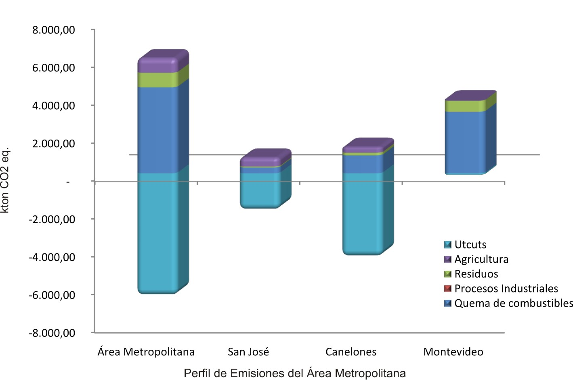
Impact map: rural sector-agriculture
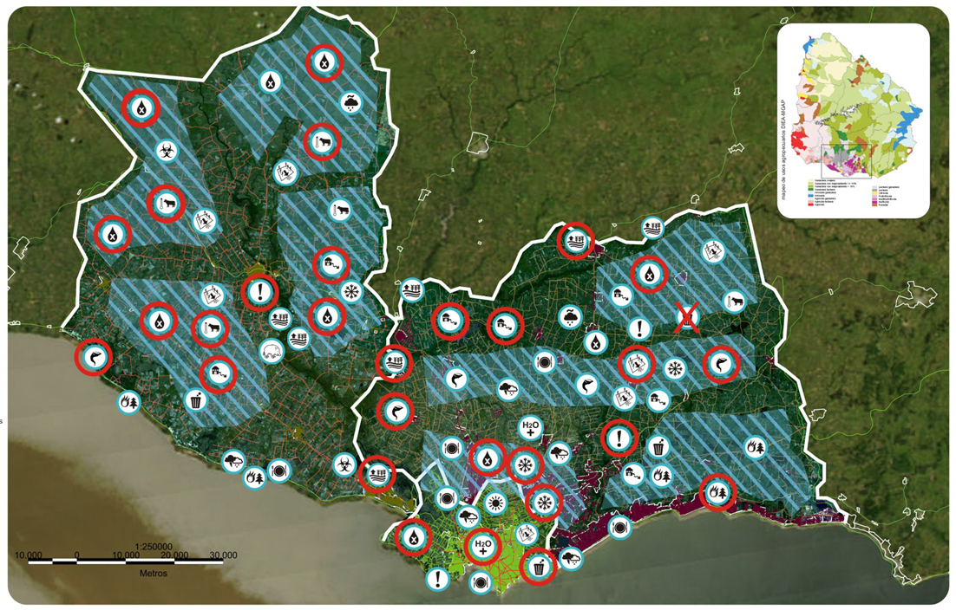

Impact map: coastal sector-San José
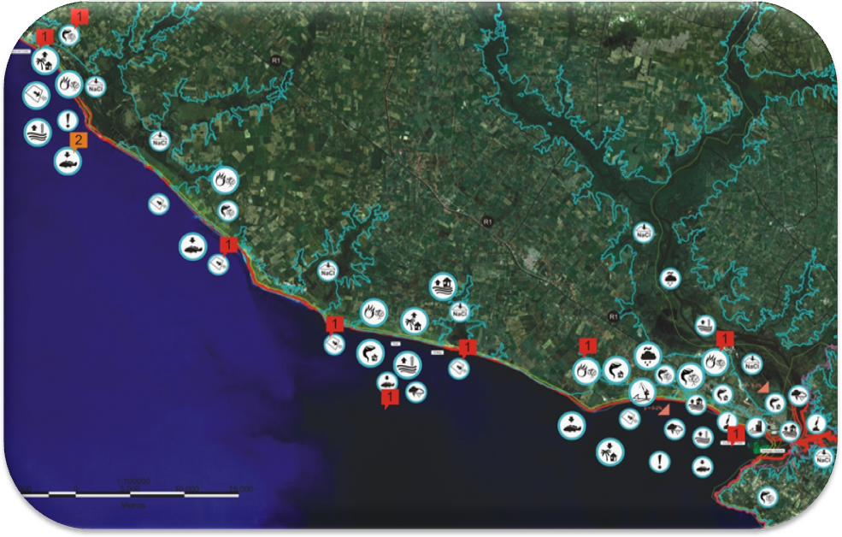

Step 3: Identify Strategic Options Leading to Low Emissions Climate –Resilient Development Trajectories.
Measures to be included in the metropolitan and departmental action plans have been participatory identified in the local working groups, with orientation given by renowned national and foreign experts. These groups have identified more than 500 measures which differ significantly in terms of sectors, timing and resources needed. This group of actions has been systematized according to strategic lines, programmes and projects of short, medium and long term. Based on this systematization, and the economic and legal prefeasibility studies currently underway, the working groups are completing the final phase of prioritization. Preliminary results for Montevideo are as follow:

Preliminary results for the prioritization of actions: Montevideo
Sector | Agriculture
Strategic line | Integrated water resources management
Prioritized action | Infrastructure development to provide water supply solutions for agriculture production
Strategic line | Climate information and insurance
Prioritized action | Promotion of public-private partnerships to create new insurance schemes aimed at agriculture SMEs and promotion of already existing insurances
Strategic line | Promotion and conservation of agro-biodiversity and natural resources
Prioritized action | Promotion of sustainable land use management, pastures and forages to increase carbon sinks and reduce producers’ vulnerability to climate change
Strategic line | Food security
Prioritized action | Identification, rescue and re-appreciation of native crop species, better adapted to local conditions, to increase resilience and adaptation to climate change
Sector | Coastal Management
Strategic line | Sustainable urbanization of coastal zones
Prioritized action | Implementation of an Early Warning and Response System for flood zones management in coastal areas
Strategic line | Resilient coastal tourism
Prioritized action | Development and implementation of good practices for tourism management, with a focus on environmental education
Strategic line | Protection of coastal morphology
Prioritized action | Restoration of sand dune systems in Montevideo coastal areas
Strategic line | Protection of biodiversity and water systems in coastal zones
Prioritized action | Establishment and/or strengthening of a monitoring system for the River Plate, focused on water quality, biota and oceanographic variables, to support the design of appropriate actions
Sector | Built Environment and Health
Strategic line | Extreme events risk reduction – Floods
Prioritized action | Integral management of flood risk areas in the department (Pantanoso Stream low basin)
Strategic line | Risk reduction of water transmission diseases
Prioritized action | Increase/improve connections to existing sewerage systems in dense areas
Strategic line | Control of increased presence of transmission vectors
Prioritized action | Strengthening of departmental epidemiological surveillance
Strategic line | Reduction of risks associated to temperature variability
Prioritized action | Scientific research promotion about heat and cold waves and health implications
Sector | GHG Emissions Mitigation
Strategic line | Implementation of a Climatic Observatory
Prioritized action | Actualization of the metropolitan GHG inventory every two years
Strategic line | GHG emissions reduction in cargo and passenger transportation
Prioritized action | Prioritization of increased quality and efficiency of public transportation in all departmental plans
Strategic line | GHG emissions reduction at residential and commercial levels
Prioritized action | Development of departmental tools to evaluate sustainability in buildings, including GHG emissions during both construction and occupation phases
Strategic line | Promotion of low emission energy sources and energy efficiency
Prioritized action | Diffusion of an energy efficiency promotion program
Strategic line | Education on “Climate Change and Variability” at all levels of formal and informal education
Prioritized action | Drafting of educational materials with a local perspective according to different educational levels
Strategic line | Development of appropriate legal and financial voluntary instruments
Prioritized action | Development of a carbon footprint label to encourage emission reduction programs
Strategic line | GHG emissions reduction associated to waste management
Prioritized action | Implementation of an awareness campaign to educate on waste generation reduction

Step 4: Identify Policies and Financing options to implement priority Climate Change Actions.
The Integrated Territorial Climate Plan will serve as a framework to access different sources of financing, such as national and departmental budgets, bilateral and multilateral funds, and/or funding from the private sector. Departmental Governments are already assigning, even before the plan is finalized, resources to implement a group of early actions identified during the process, such as strengthening water supply for small rural producers facing drought forecasts. Additionally, two adaptation and local development projects have been submitted for international financing. The first relates to sustainable family dairy production; the second to native species nurseries managed by rural women and young population. The former is currently under implementation; the latter has been pre-selected and is awaiting final approval.

Step 5: Prepare Low Emission Climate Resilient Development Roadmap.
The design and consultation phase for the development of the LECDRS is expected to be completed by 2012. In the final year, the focus will shift to implementation of additional early actions activities and drafting of project profiles and documents to access other sources of financing.

Additional results:
- Appropriation of concepts and methodology: awareness and capacity building methodologies designed and implemented by the project are being replicated in the whole country through the National Climate Change Response System.
- Mainstreaming: a mainstreaming/multisectorial approach to climate change has been consolidated within the three departmental governments participating in the project. In the case of Montevideo, the Governor formally created a Working Group on Climate Change by resolution dated September 13, 2010.
- Network building: the project co-organized a World Summit of Regions in April 2010, with the participation of more than 500 local representatives from around the world, fostering networks and associations, and with local approach to climate change.
- Emergency response: the project contributed to generate the right conditions for the creation of the Departmental Emergency Coordination Center in San José, after previous unsuccessful attempts.

