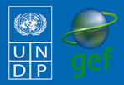
Community-Based Adaptation
FAST FACTS

Grantee: Fundación Natura Bolivia
Type of organization: NGO
Number of participants: 3,366
Location: Moro Moro , Bolivia
CBA Contribution: $34,875 USD
Project Partners: IUCN
Co-financing: $10,165 (in cash); $42,000 (in-kind)
Project Dates: March 2009 – August 2010
BOLIVIA
Sustainable management of water and soils: knowledge and tools to improve community adaptive capacity and reduce vulnerability in the municipality of Moro Moro

BACKGROUND
The Community-Based Adaptation Programme (CBA) is a five-year UNDP global initiative, largely funded by the Global Environment Facility (GEF) along with other donors. Delivering through the GEF-Small Grants Programme (SGP) and UNDP Country Office, the goal of the Project is to strengthen the resiliency of communities addressing climate change impacts. UNDP partners with the United Nations Volunteers (UNV) programme to enhance community mobilization, recognize volunteers’ contributions and ensure inclusive participation around the project, as well as to facilitate capacity building of partner non-governmental organizations (NGOs) and community-based organizations (CBOs). Testing the Vulnerability Assessment Reduction (VRA) and other community-engagement tools, the Project is generating invaluable knowledge and lessons for replication and upscaling. The Government of Japan, the Government of Switzerland, and AusAID provide additional funding.
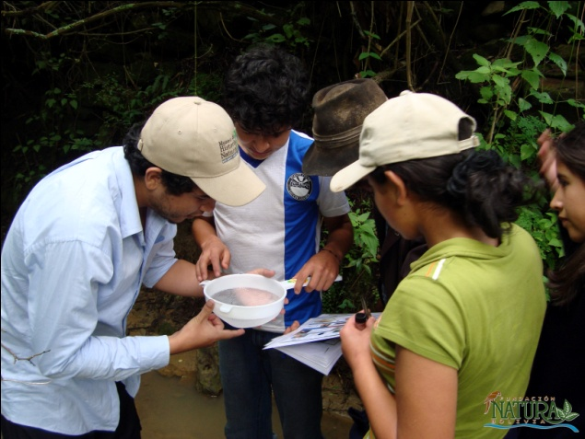
The CBA project “Sustainable management of water and soils: knowledge and tools to improve community the adaptive capacity and reduce the vulnerability in the municipality of Moro Moro” is located in Santa Cruz Department of Bolivia. Moro Moro has a wide altitudinal range from 1100 to 3000 meters above sea level and consists of three ecological zones: subtropical, lower valley and upper valley. Its topography is mountainous, with rugged terrains, steep slopes and rocky outcrops interspersed with rocky areas. The temperature in Moro Moro varies from an average of 22 ° C at the bottom of the warmer valleys up to 16.8 ° C in the upper valley slopes. The average annual rainfall is 681.6 mm. More than 90% of the rainfall happens during the wet season (December to March). During the dry season (April to November), with June and July being critical months for agriculture, the rainfall is 7mm per month. June and July are critical months for agriculture, the main economic activity in the area. Declining water resources brought on by climate change poses a threat to the water consumption and irrigation needs of the community members, 80% of whom do not have drinking water systems in place. Additionally, the original vegetation has been greatly affected by human activity, especially in the upper valleys where most people live. Today, agricultural soils have low fertility, and forces activity on the already pronounced slopes and removing remnants of protective forests in the headwaters of rivers. Over 40% of soils are not useful for economic activities. Livelihoods in the project area are threatened by prolonged droughts, serious deforestation, soil degradation, deterioration of forage resources and declining water resources caused by climate change impacts such as torrential storms with intensified winds, erratic rain patterns and increases in temperature. In addition to threatening agricultural productivity on steeply sloped pastures, farmlands and livelihoods in the upper valleys, soil degradation and deforestation has serious implications for water quality and quantity for populations living downstream.
Collection of micro invertebrates from the water as part of water quality monitoring activities
Contact information: Project Management Unit at cba@undp.org
220 East 42nd St., 21st Floor New York, NY 10019 Tel: (646) 781-4402
For more information about CBA or CBA projects visit: www.undp-adaptation.org/project/cba

CLIMATE CHANGE RISKS
Climate change impacts are already becoming apparent in Moro Moro. Projected impacts include increasing temperature, increasingly intense yet erratic rainfall, and more marked seasonality, which in turn increase the risks of both floods and droughts. These changes will worsen baseline land degradation pressures, and threaten to undermine other work on water and soil management being done in the region by the proponent and by its partners in IUCN and UNDP-Bolivia, which focus on integrated water resource management through an environmental services payment scheme. Without adaptation measures on the risks, the communities’ livelihoods and existence are at risk.
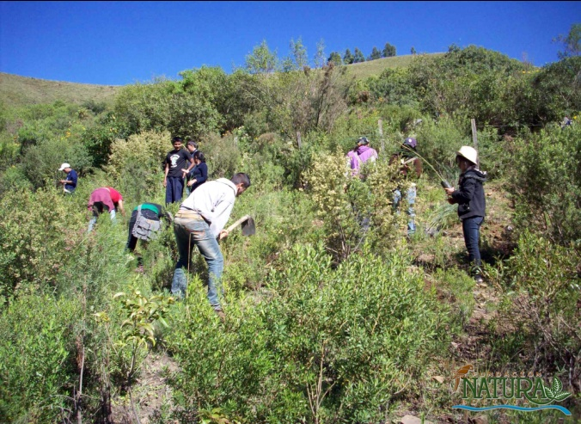
PROJECT DESCRIPTION AND
ADAPTATION SOLUTIONS
The CBA project aims to sustainably manage forest lands and its resources to protect native species, soils, and ecosystem services (flood, erosion, and landslide protection) it provides to stem against climate change risks. Through a participatory approach, the project enhances the knowledge of the community members and establish a system for local monitoring of changing flow and quality of principle water sources, develop climate change adaptation practices and integrate climate change risk management into municipal policy. The project increases the adaptive capacity of local communities through the following activities:
- Design a local-level adaptation plan, based on the combination of community knowledge and scientific data.
Students working on reforestation.
- Participatory analysis of historical climate variability and its impacts on production and other factors, to serve as a baseline, and to contribute to understanding properly the impacts stemming from climate change.
- Participatory development of a community plan for protecting key hydrological recharge zones (acquifers) through reforestation.
- Physical and chemical analysis of local water flow parameters (Moro Moro river), including data from several flow measurement points, will help the design and installation of automated climate measurement station (to be linked to the national meteorological network).
- Capacity-building workshops on local use of water and climate monitoring technology ( on water flow and climate change parameter measurement systems) to inform the members of ongoing adapatation activities.
- Systematized information on community-based climate measurement, and on transfer of climate measurement technology to communities.
- Reforestation of riparian fringes and lands without vegetative cover (according to the community-driven reforestation plan) to minimize increasing contamination, sedimentation and flood erosion risks. Plans developed include private lands within adaptation frameworks though an environmental services payments scheme. Evaluation of potentials for involving private landholdings in adaptation measures through a participatory environmental services payments framework. Negotiations with landholders for including private landholdings in adaptation measures through an environmental services payments framework.

This project increases the community awareness and adaptive capacity through an aggressive outreach and training component on sustainable forestry and resource management to protect native species, soils, and ecosystem services (flood, erosion, and landslide protection) from climate change risks. Lessons learned will be shared with neighboring municipalities.
FOCUS ON...
Global environmental benefit
Practices developed are aimed at improving the soil management, reducing erosion and improving water availability both in quantity and quality in efforts of reducing the vulnerability to climate change and contributing to global environmental benefits.

Community participation and sustainability
The ability of the inhabitants to adapt to environmental changes depends on their understanding of climate change and their capacities to distinguish between natural impacts, human pressures and climatic factors. In this regard, the project was developed and implemented through a participatory approach. Awareness-raising workshops were held to know how the community members perceived the impacts of climate change and help them identify the most appropriate adaptation actions. Monitoring and evaluation systems for water flow changes and the water quality in the Moro Moro River was done by communities. Community members obtain regular data on the quality and quantity of water available in watersheds so they are able to identify where to perform protective actions, determine what actions are best suited and tailor actions according to changes of conditions. This approach enhanced the skills of the communities, as well as providing them with tools to sustainably adapt to climate change. With IUCN’s partnership, the implementation of the resource management plans in the Rio Grande Valley of Santa Cruz also included neighbouring municipalities: Postrervalle, Pucara, Samaipata and Vallegrande.

Policy Influence
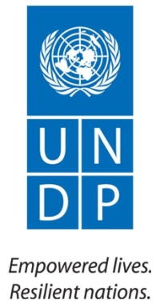
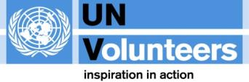
Adaptive water and land resource management to climate change risks that were learned from the project was aimed at influencing municipal policies to reduce soil degradation and sources of water pollution. These policies included the zoning of key areas: areas used strictly for conservation of land, water and species, and areas used to undertake sustainable development activities using natural resources. Maintaining the biological integrity and water in the protected zones promotes economic development and long-term financial sustainability.

