Water Model

A simple water model is developed to illustrate the importance of water allocation as an adaptation to climate change. There are two users in this model: farmers and households. Households represent the demand by villagers, municipalities, and industry. Empirical studies in Asia have shown that municipalities, households, and industry have more price inelastic (steeper) demand functions than farmers. This is captured in this model by the relatively steep demand given to households. Empirical analysis also reveals that the marginal value farmers place on their current allocation of water is lower than the marginal value that these other users place. We have assumed the initial allocation leaves a 10 to 1 ratio although this can be adjusted simply by reallocating water.
We have assumed that water is scarce. That is, current withdrawals use up the available water. If there is more water available than is being used, the price of water is zero, and there is no economic loss associated with losing water (until water becomes scarce).
The data page provides information about national averages for each country. If you do not know anything about the specific uses in the basin you are studying, it is reasonable to use the national averages. It is always preferable to use the data from each basin.
The model itself is on the second excel sheet. The model examines every possible allocation of water between the two users. The mode calculates the marginal value of water to each user given the allocation (see Figure 1). The marginal value is the implicit “price” or scarcity of water even if there is no charge. The model also calculates the aggregate value to each type of user and the total value of the water system. The aggregate value to each user is the area underneath the demand given the allocated water to that use (see Figure 2). The aggregate value to society is the sum of all the values across all users. One can see how the total value of the water changes as one reallocates water by scrolling down the column and looking at each row.
The water allocation that equates the marginal value of water between the two users maximizes the aggregate value.
One can use the model to look at changes in supply (climate change). In box D8, one can change the fraction of water available. For example, one can place in the box, “=D7*.75”. This would remove 25% of water supply. You can see immediately that the marginal value of water goes up in every cell and that aggregate values go down. The key insight however is that marginal values go up more for households than for farmers. One can adapt to reductions in supply by making sure that households do not lose very much water (farmers lose more water than households). This reallocation reduces the economic loss associated with the loss of water.
Note that if the flows increase, prices go down and the aggregate value of the water system increases. In this case, you want to give farmers more of the additional water than households. Thus it is farmers that bear the brunt of the changes in water supply (lose water when water is scarce and gain water when water is abundant).
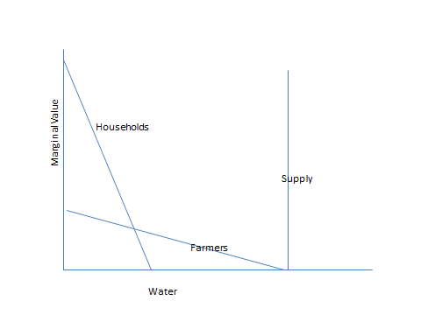
Figure 1: Demand and supply functions of water model

Figure 2: Aggregate value of water to farmers 