NAP Regional Training Workshop for Asia
Session 2: Climate Information and Services
EXERCISE: Risk mapping and hazard identification

Instructions for the exercise

- Divide in 4 working groups at random or by sector or country.
- Place 4 tables in the corners of the room, each providing copies of the relevant matrices and maps in colour.
- Each group to work in joint discussion on 1 set of matrix and maps (1 set per trainee), and identify risk types and areas most at risk in the land-use map. The groups might use any technique (marker, dots etc.) to document their findings.
- Place all 4 working maps on a pin board in front of the room for the wrap-up.
Part B.1: Risk mapping
In this exercise, you are invited to reflect the impacts of specific hazards to key sectors and geographical areas. This will allow you to think about the type of information you will need as to plan and mainstream climate risks into NAPs.
You will focus on flood-prone areas in South East Asia. An existing risk assessment has determined inundation levels from extreme events (heavy storms / typhoons) for the current situation (Fig. 1) and for a projection for the year 2030 (Fig. 3). You will be provided with relevant maps indicating the historical precipitations (Fig. 1), current water-related hazards (Fig. 2 and 3), projected inundations (Fig. 4) as well as a map of the existing croplands (Fig. 5) and population density (Fig. 6).
Figure 1: Average annual precipitation 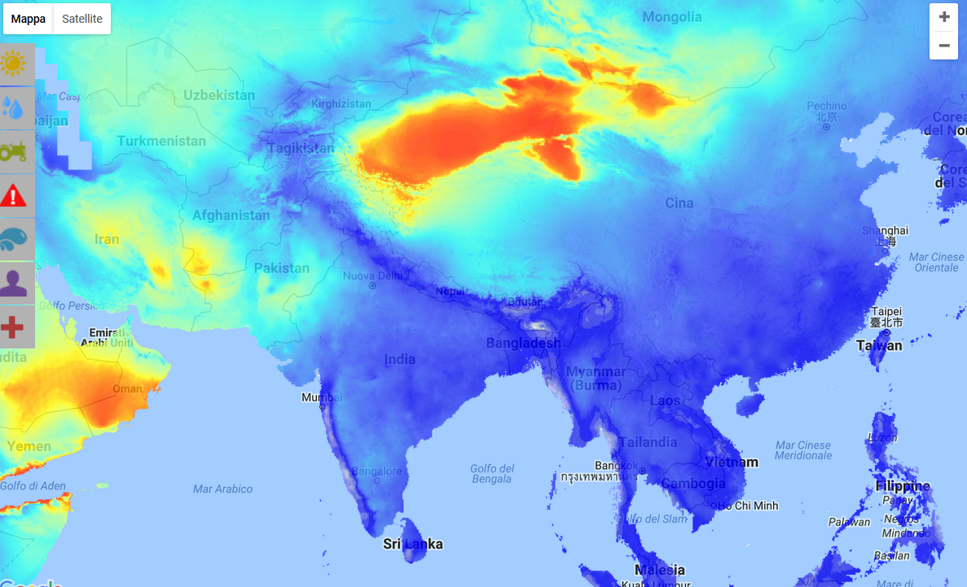

Figure 2: Current natural hazards – Cyclones
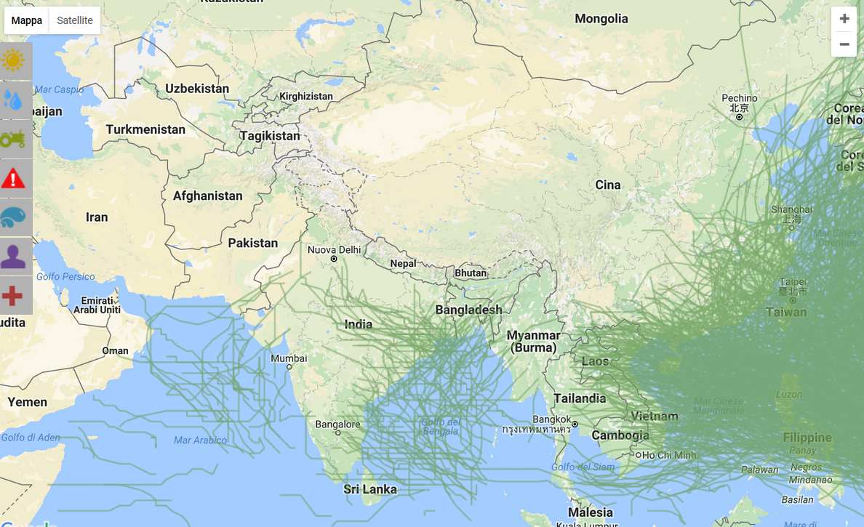
Figure 3: Current natural hazards – Floods
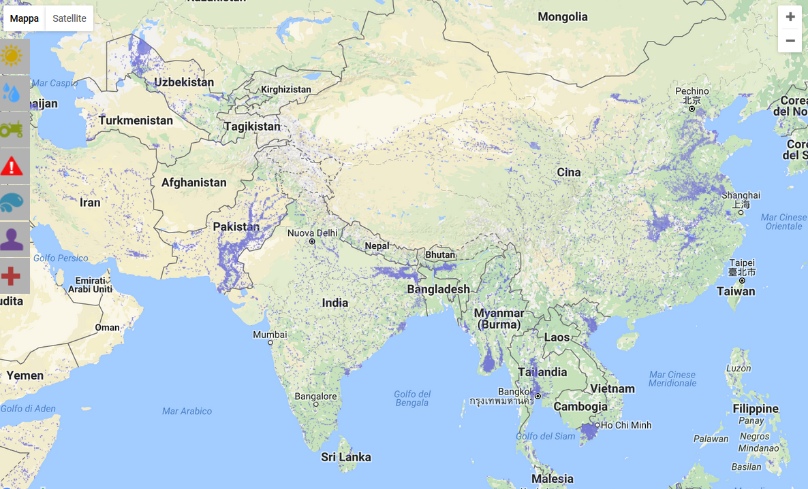
Figure 4: Extreme event flooding projected for 2030
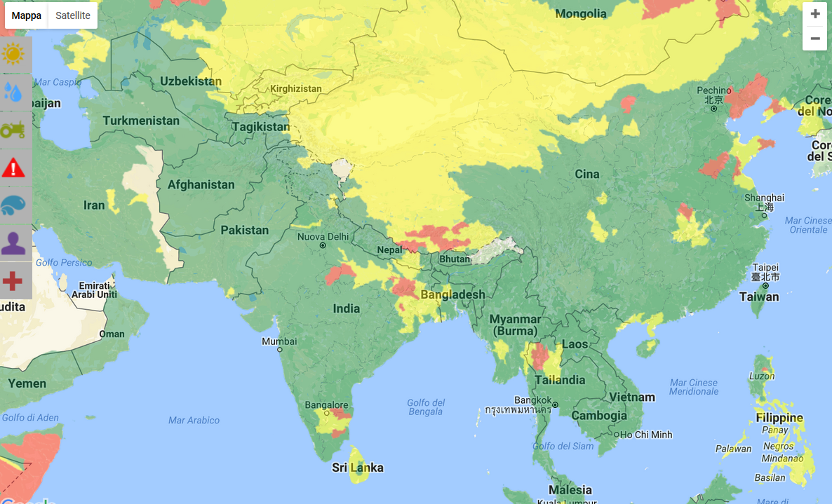
Figure 5: Existing cropland
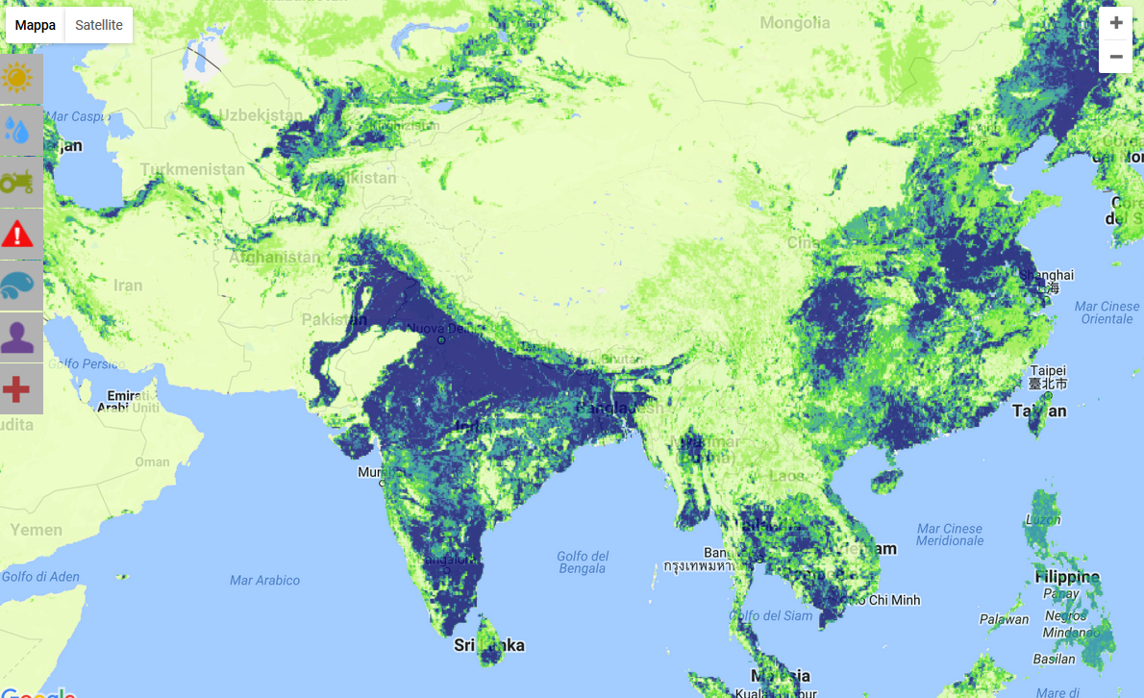

Figure 6: Population density at 2015
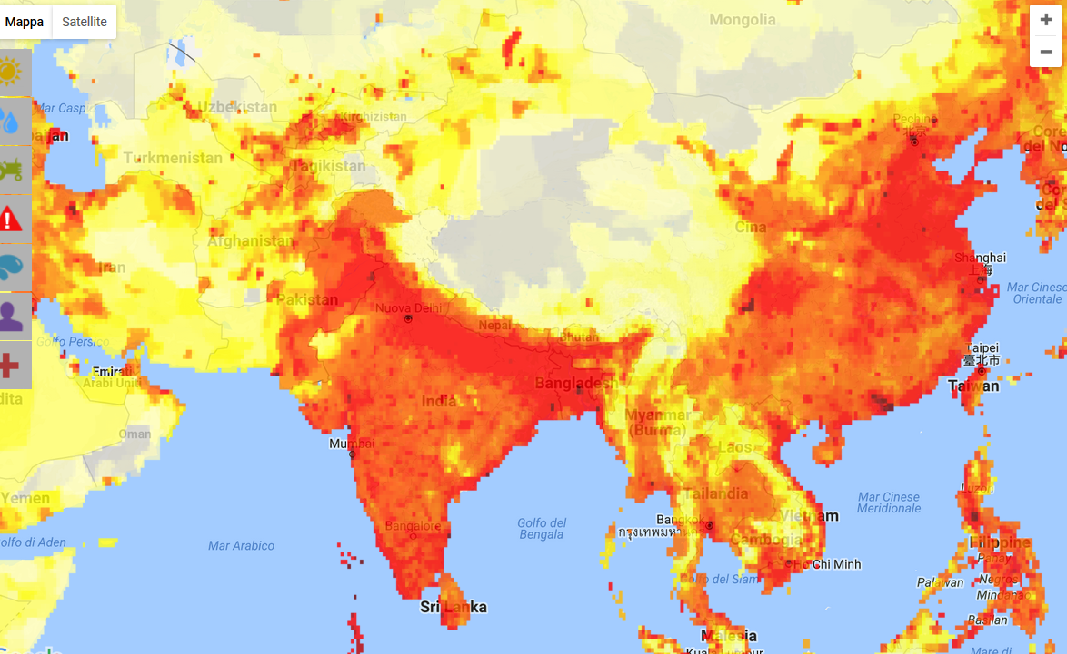
As a basis to determine future adaptation options you are tasked to identify the regions, which are most at risk (i.e. you will determine the “key risks” of the area under investigation, according to IPCC AR5 terminology). Risks are generally considered key due to a) high hazard, b) high exposure, c) high vulnerability, or d) a combination of these factors. Please work with your colleagues in sub-groups on the maps provided and answer the following questions:
- What areas or sectors are most at risk of flooding in the area displayed on the map? Agree on the criteria to be applied and visualise the results of your discussion on the map print-outs through colour markers, stickers etc.

Sector | Risk-type posed by climate change? | What kind of climate information will you need to understand the type, magnitude spatial and temporal scale of the climate risk? | What adaptation options might be relevant to the risk typology? | What actors should contribute to provide climate information services?
Water
Agriculture
Health
Migration

Guiding questions for wrap-up
- Which information did you receive from which map?
- Which key risk areas or sectors did you identify?
- How did you do that? Which criteria did you apply?
- Which information would you need for more precise risk and vulnerability assessments?
- Who could / should commission / conduct the risk and vulnerability assessment in your country in the context of the NAP process?
- How should the results of future risk and vulnerability assessments in the context of the NAP process be used (e.g. for identification of adaptation options, M&E of adaptation measures)?
- Can you compare the method with risk and vulnerability assessment approaches already applied in your country?
Part B.2: Hazard identification
Within the preparatory steps for the NAP process, it is important for you to gain a better understanding of the existing or potential future risks involved in climate change for your country or your sector, and assign priority to specific hazards in agreement with different stakeholders such as representatives from different ministries, departments or sectors of society. You may consider the hazards in your country which appear relevant to you/your sector, based on the matrix below which summarizes four hazard typologies.

Dry/Cold | Dry/Warm
Wet/Cold | Wet/Warm

Place the red sticky dots on the prepared matrix and develop a hazard priority map.
Reference material:
- WMO (2016), Climate Services for Supporting Climate Change Adaptation: Supplement to the Technical Guidelines for the National Adaptation Plan Process;
- WMO (2016), Use of Climate Predictions to Manage Risks;
- WMO (2015), E-tutorial on GFCS;
- WMO (2011), Guide to Climatological Practices;
- WMO (2010), Role of NMHSS in Adaptation to Climate Variability and Change.
Risk-mapping interactive tools:
- World Bank Knowledge Portal – World Bank
- ClimateWizard - The Nature Conservancy
- Climate Information Platform – CSAG, University of Cape Town
- Food Insecurity & Climate Change - WFP & UK Met Office
- I-TACs – Japan Meteorological Agency
Contact information:
Mr. Amir Delju - adelju@wmo.int
Ms Ilaria Gallo - igallo@wmo.int
WMO’s webiste - https://public.wmo.int/en

