**SESSION 3 – EXERCISE SHEET**

**Vulnerability Assessment for Country X (Zanadu)[1]**

**Learning Objective for the Exercise:**

Learn the first step of the systematic approach to climate change adaptation: identify factors contributing to vulnerability in a system (sensitivity and exposure to climate signals resulting in potential impacts as well as adaptive capacity) and prioritize where action is needed. This step establishes the basis for integrating adaptation into development efforts.

**Exercise Description:**

The Vulnerability Assessment is divided into two parts. Each group will undertake Part 1 and Part 2 of the exercise. Due to limited time, each group will focus only on specific system of interest related to the water sector. The facilitators should make sure that the groups manage to integrate findings from VA Part 1 in discussions in VA Part 2

In part 1, participants gather information to understand the recent situation of the systems of interest. It deals with the recent situation in the system of interest: stocktaking of actors and assets in your system of interest and an analysis of their recent sensitivity and adaptive capacity. This will help them to do a comprehensive assessment of the vulnerability/the need for action in part 2.

Part 2 deals with the future under climate change. It works through potential impacts on the biophysical and socio-economic components of the system of interest and finally define the vulnerability / need for action. Information from part 1 (sensitivities and adaptive capacities) supports this assessment.

Handouts will be provided to give the context/background of the exercise.

*Context*

The National Water Policy of Zanadu has been recently updated with goals and priority pro-grammes for 2015-2025. The Ministry of Water (MoW) in cooperation with the Ministry of Agriculture (MoA) has requested each state to review and update their State Water Programmes in line with the new National Water Policy.

Development cooperation partners have pledged financial support for the integration of climate change adaptation into the State Water Programmes. Funding will be allocated for the design and implementation of priority activities to improve sustainable water management under climate change.

In South State, the revision of the State Water Programme will be conducted by the State Water Authority (SWA). SWA’s mandate is to sustainably manage surface and groundwater for multiple uses. These include agriculture, drinking water supply and sanitation, flood control, navigation and recreation.

Each group is an advisory group to the SWA to support the integration of climate change adaptation in the revision of the South State Water Programme. The SWA has decided to focus the revision on two key areas:

1. **Increased and diversified agricultural production and rural incomes:** In order to contribute to this NDP goal, the revision of the State Water Programme aims at maintaining a balance between future water supply and demand for the three important agricultural systems: (a) the rice/wheat rotation in the central plain, (b) upland plantation agriculture and (c) the delta rice growing.
2. **Safe drinking water supply and sanitation:** In order to contribute to this NDP goal, the revision of the State Water Programme aims at ensuring safe drinking water supply and sanitation for 80% of population by 2020 for all three systems (capital city of Maja, 5 medium cities, rural areas).

**INSTRUCTIONS:**

**Exercise grouping** [15 minutes]

1. Group the participants into 6 (mixed group of 8-10 participants per group).
2. Each group will undertake Part 1 and Part 2 of the exercise. Allow time for the groups to read the background information on the exercise. Due to limited time, each group will focus only on specific system of interest related to the water sector. The facilitators should make sure that the groups manage to integrate findings from VA Part 1 in discussions in VA Part 2.
3. Proposed grouping (based on the exercise context provided):

|  |  |  |  |
| --- | --- | --- | --- |
| **Agriculture**  *Development Goal: Increased and diversified agricultural production and rural incomes* | | **Water Supply and Sanitation Systems**  *Development Goal: Safe drinking water supply and sanitation to be available for 80% of population by 2020* | |
| 1 | Rice/wheat rotation in the central plain | 4 | Maja City |
| 2 | Upland plantation agriculture | 5 | Five (5) medium cities |
| 3 | Delta rice growing | 6 | Rural Areas |

**Assess Vulnerability Part 1** [40 minutes exercise, 20 minutes sharing of experience]

1. Use VA Matrix 1 to guide the group work.
2. First, brainstorm the natural and social assets (e.g. crops, equipment, community institutions) and relevant actors (e.g. farmers, labourers, traders) within the system.
3. In column A, list climatic changes already experienced, such as changing precipitation patterns (e.g. late onset of the rainy season), temperature extremes, etc.
4. In column B, consider if and how the system of interest’s actors and assets are currently sensitive to climate variability. Think of ecological and social sensitivity. Examples of sensitivity factors are local housing materials, crop water requirements, resource dependency of a community.
5. In column C, elaborate the system’s current adaptive capacity, e.g. a clearly negotiated value chain leaving farmers enough share or access to reliable seasonal weather fore-casts would increase the adaptive capacity of a community.

|  |  |  |  |
| --- | --- | --- | --- |
| **System of Interest** | **A** | **B** | **C** |
| **Current Climate Variability** | **Current Sensitivity** | **Current Adaptive Capacity** |
| **Group 1 :** Rice/wheat rotation in the central plain | * Extended drought period * Heavy rainfall in short periods of time * Increasing number of hot days per year | * Limited water resources (seasonal precipitation, almost the whole area is already under irrigation) * Rice varieties commonly used are sensitive to even small temperature changes * Dependency of rural communities on employment in agriculture | * Growing service sector in the State offers other employment opportunities (alternative income) * Ability of farmers to access forecasts and adjust cropping calendar accordingly |
| *Assets* |
| Irrigation system in place |
| … |
| … |
| *Actors* |
| Farmers |
| … |
| … |

**Assess Vulnerability Part 2** [40 minutes exercise, 20 minutes sharing of experience]

1. Keep in mind the concepts of risk and vulnerability introduced in Session 2 (reconciled IPCC AR4 and AR5 concepts and terminologies):

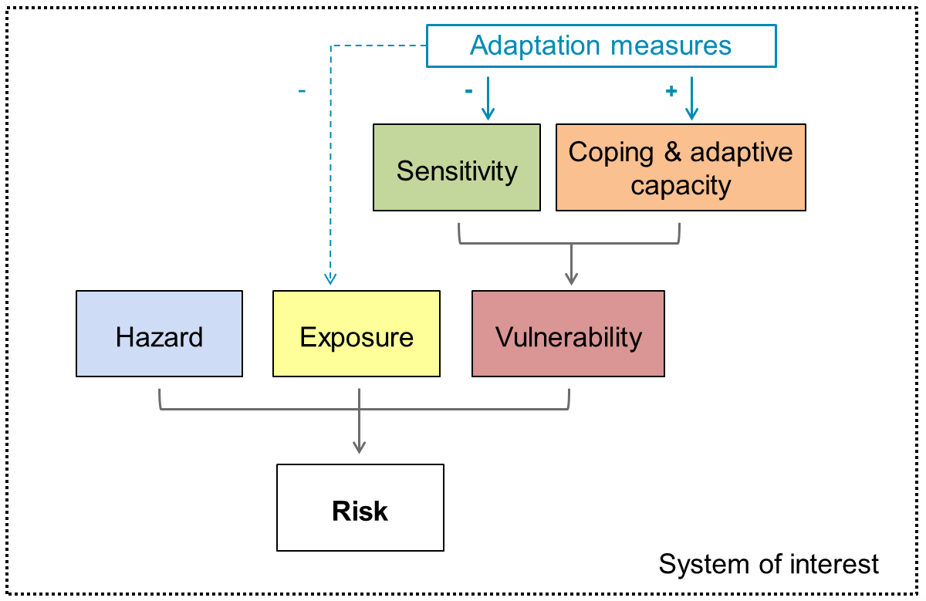

*Source: Adapted from Vulnerability Sourcebook (GIZ 2014); adapted to IPCC AR5 definition*

1. Use VA Matrix 2 to guide the group work.
2. In column D, identify the key climate change signals of concern. Review information provided about South State and in Exhibit 2. (If you did M2 use what you have learned.).
3. In column E, brainstorm the potential impacts to the biophysical part of the system by considering column D in combination with the sensitivity factors (part 1 column B), e.g. dry spells lead to lack of groundwater recharge.
4. In column F, brainstorm socio-economic impacts that you expect to result from climate change (column D) and the biophysical impacts (column E). Also take into account sensitivity factors (part 1, column B). You may also want to consider positive impacts. E.g. reduced production and loss of income as there is not enough water for irrigation.
5. In column G rate vulnerability on a scale from 1-5. This gives an indication of the need for action:
   * Recall that vulnerability is a function of exposure, sensitivity, and adaptive capacity; and that oftentimes, development action addresses vulnerabilities.
   * Discuss columns E and F using the following questions:
     + How relevant are the potential impacts to the development objective?
     + How likely is the impacts’ occurrence?
     + What is the extent of expected damage?
   * Take into account adaptive capacity (part 1, column C). If the system can deal with impacts without external support, it is considered less vulnerable.
   * Summarize the group’s findings by indicating 1-5 for the extent of vulnerability (5 = highly vulnerable).
   * Add a short explanation (for documentation).

|  |  |  |  |  |
| --- | --- | --- | --- | --- |
| **System of Interest** | **D** | **E** | **F** | **G** |
| Climate change signals the system of interest will be exposed to | Potential biophysical impacts (also considering  sensitivity – Column B) | Potential socio-economic impacts (also considering  sensitivity – Column B) | Rate vulnerability and need for action 1-5 (also taking into account adaptive capacity – column C) |
| **Group 1 :** Rice/wheat rotation in the central plain | * Projected increase in temperature of between 1.4 and 2.0 degrees C by 2050s * Later arrival, shorter duration of seasonal heavy rains * … * … | * Rice sterility with temperature increase * … * … | * Decreasing rice yields * Loss of income * … * … | 4: very vulnerable, high damage if less production possible |
| *Assets* |
| Irrigation system in place |
| … |
| … |
| *Actors* |
| Farmers |
| … |
| … |

**HANDOUT 1: Key Features of Zanadu**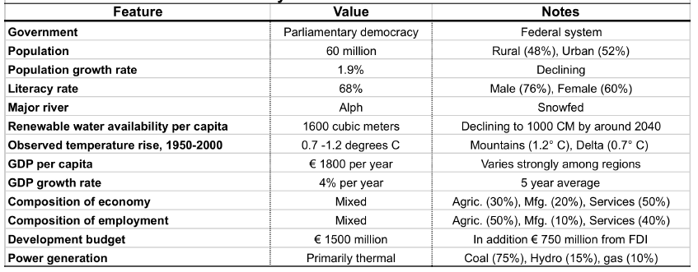

**HANDOUT 2: Map of Zanadu**



**HANDOUT 3: Introduction to South State**

South State is the largest, richest and most populous of the three states of Zanadu.

* Area: 140,000 km2
* Cultivated area: 50,000 km2 (5 million ha)
* Irrigated area: 20,000 km2 (2 million ha)
* Population: 40 million
* Population density: 321 per km2

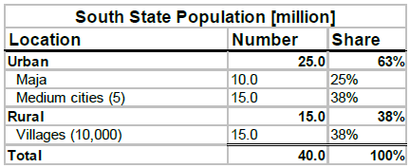

**Geography**

The central part of the state is a large fertile alluvial plain, bisected by the River Alph. The Alph has created a large delta of fertile sediments where it empties into the sea. Much of the delta lies just a few metres above sea level. Most of it is protected on the sea side by mangroves. To the east of the floodplain lies a range of low coastal hills and on the other side of them, a narrow coastal plain that features extensive swaths of white sandy beaches along the seashore. A fringing coral reef lies just offshore. This area has major tourism potential, though facilities are largely undeveloped.

To the west, the land rises toward a plateau which forms most of West State. Demographics South state’s population of 40 million is two-thirds urban. In addition to the national capital, Maja, which has a population of 10 million, there are five other large cities in the state with a total population of 15 million. Three of these are located along the Alph and two are inland. The rural population of 15 million resides in some 10,000 villages and small towns scattered across the state.

Almost all of the population growth is concentrated in the urban areas and comprises a combination of in-migration from rural areas and natural growth.

**Economy**

The state is the richest in the country, but also has the largest pockets of poverty. Agriculture con-tributes 20% to the state’s GDP and provides the employment base for 40% of the state’s work-force (direct and indirect). The small but growing high-tech sector has considerable potential. There is a growing demand for electricity, which is currently inadequate.

There is an extensive textile industry based on the state’s cotton. Cocoa processing has existed since the colonial era and a palm oil industry for both culinary and biofuel uses is undergoing rap-id expansion, driven by foreign investment, as a result of rising prices and biofuel mandates and subsidies in Western countries.

**Agriculture**

The Alph River plain is the breadbasket of the state and the country and supports an extensive **rice/wheat crop rotation**. Rice is grown during the highly seasonal rainfall in summer, followed by wheat in the dry cool winter season. Almost all of this area is irrigated from large government diversion structures and canal systems on the River Alph. Irrigation for the summer rice crop is supplemental to rainfall. The winter wheat requires irrigation to produce a viable crop.

Further away from the river lies a pair of productive rain-fed **cotton** belts, one on either side of the lower flood plain. **Maize** is also grown in the cotton belt, interspersed with the cotton fields. Some of these fields are irrigated from private wells.

In the Alph Delta an extensive area is sown to rice in both seasons, though localised flooding from the heavy seasonal rainfall in summer can prevent rice growing in some areas during the summer. Much of the rice is irrigated from simple canals drawing water from the many natural distributaries of the Alph branching through the delta.

**Plantation crops (cocoa, palm oil)** are grown in the low hills in the north of the state. **Native forest** is currently being cleared to allow for expanded production of palm oil. Some growers of both cocoa and oil palm, usually the larger ones, are experimenting with drip irrigation from private wells.

Farm sizes on the Alph River plain are generally small – in the order of three to five hectares. In the Alph River Delta, farm sizes are very small – on the order of 1 or 2 hectares. In the maize and cotton belt, farms are larger – typically on the order of 10 to 20 hectares, but some of the cotton farms are considerably larger. The plantation crops are generally produced on large family or corporate farms. Cropped and irrigated areas are shown below.

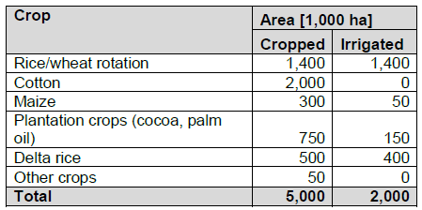

**Water Supply and Sanitation**

The capital city of Maja distributes treated surface water from the Alph to serve 70% of the city’s population. In the five medium cities, supply is from pumped groundwater. In the rural areas drinking water is drawn entirely from groundwater. Often this comprises one or several dug communal wells.

About 20% of the wastewater is treated and returned to the river. The remainder of the wastewater flow is piped to an offshore outfall. All five of the medium cities use groundwater as a domestic and industrial water source and, overall, provide piped water to about 50% of their population. All cities have a basic sewerage collection system, but wastewater is discharged into the Alph or a tributary after only primary treatment. Discharge water is typically high in coliform bacteria and sometimes industrial pollutants. In the rural areas there is no wastewater collection or treatment. Wastewater infiltrates into the ground or flows in natural drainage ways to tributaries of the Alph.

**Hydrology**

Alph River discharge is highly variable across the seasons, with peak flows in July and August at the height of the highly variable summer rains. There is also great variability from year to year. Snowmelt provides much of the flow during the spring before the arrival of the summer rains. Available water during the low flow period following the summer rains is almost completely utilized for irrigation, municipal supply and to maintain navigation access in the country’s major port near Maja. Hydrographs for the periods 1975 to 2000 and for 2040 to 2060 are shown below.

Groundwater tables near the river are fairly stable. Further away from the river, levels are dropping at a rate of around 1 to 2 metres per year. In the upland and hilly areas, groundwater is unevenly distributed – present in some places and absent in others. Levels have begun to drop in recent years as more farmers develop groundwater for irrigating maize and plantation crops.

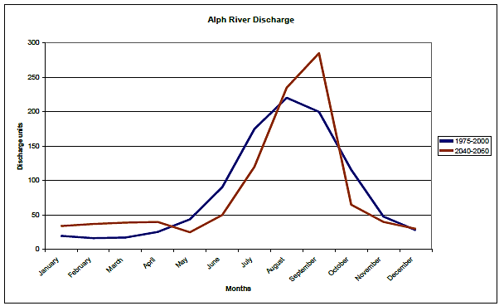

Figure 1. Historical and projected Alph River hydrographs.

**Climate Challenges**

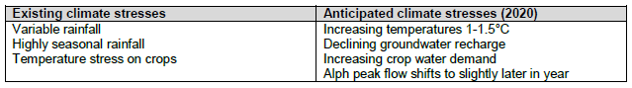

The desired economic growth (increase in agriculture, development of tourism potential, etc.) and population growth place a growing demand on water and electricity supply. Some additional indirect or mutually reinforcing climate change impacts on key development features are presented in the following.

*Power supply*

Hydropower does have development potential, but that potential may be threatened or rendered very costly by increased sedimentation of the river system.

*Water supply and sanitation*

Increased water supply from groundwater may amplify the already existing problem of sea water intrusion in coastal aquifers. Should water supply become costly, this will have immediate effects on the rural and urban poor.

Cities operate sewerage systems, whose capacities might not suffice in situations of higher rain-fall and high velocity water flows. These might be at risk considering the projected submergence of about 10% of the river delta.

*Agriculture*

The Alph River discharge units are projected to change considerably (Figure 2). This will affect the existing irrigation structures (dams, channels, etc.). The functionality of these structures may also be jeopardised by the projected increase in water velocity during rain events and the result-ing higher siltation load.

Agriculture in the riverbed, making use of residual soil moisture and/or rain-fed agriculture schemes will be especially affected by changing discharge schemes and unreliable precipitation patterns. Such systems are especially important for poorer farmers who cannot afford irrigated cultivation.

The nexus of ‘clearing native forests for plantation followed by increased erosion and sedimentation’ will have a deteriorative effect on the groundwater recharge. This is likely to be due to increased run-off and is therefore additional to the projected reduced recharge of shallow ground-water. As a result a race to the bottom may start, leaving the majority of small farms without enough water since they are unable to increase the depth of their water wells.

The South State, and mainly the agricultural sector, is highly dependent on transnational waters, especially during the summer when the Alph River is mainly fed by glacial water from Khoresia.

**HANDOUT 4:**

**Climate change information and projected impacts for Zanadu.**

**Climate information**

*Temperature*

* Rising by 2 to 4 degrees C in the Khorus Mountains by the 2050s.
* On the plains, expected rises of between 1.4 and 2.0 degrees C by the 2050s (compared with 1940-60 average).

*Precipitation*

* On average only a slight increase in annual precipitation by the 2050s compared with the 1970 to 2000 average.
* More autumn and late winter precipitation in mountains to fall as rain rather than snow.
* Higher intensity rainfall events with longer periods between events.
* Later arrival, shorter duration of seasonal heavy rains

*Sea Level*

* Rise in sea level of 0.2 to 0.4 metres expected by the 2050s.
* Warmer sea surface temperatures.

**Projected impacts**

*Surface hydrology*

* Snowmelt runoff begins 2 to 4 weeks earlier by the 2050s.
* More variable river flows.
* More frequent floods during summer.
* Longer periods without significant precipitation.
* Lower late summer river flows.
* Higher reservoir evaporation losses.
* Increased erosion of sloping land and reservoir catchments.
* Larger sediment loads in lower Alph.

*Groundwater hydrology*

* Recharge to shallow groundwater reduced by 15 to 25% by the 2050s.

*Coastal areas*

* Submergence of about 10% of the Alph river delta by the 2050s.
* Increased incidence of tidal inundation and storm surges in Delta.
* Shallow coastal aquifers become more saline.
* Saline tidal bores push further up the Alph.
* Less frequent but more intense cyclone impacts.

*Agriculture*

* Cotton yields not affected by 1-2°C temperature rise.
* Maize and wheat yields depressed by 1-2°C temperature rise.
* Rice threatened with sterility by higher temperatures during flowering.
* Plantation crop yields enhanced by warmer temperatures (assuming water availability).
* Crop water requirements increase by 3-5% by 2050.
* More frequent crop failures due to floods and droughts.

**HANDOUT 5: Role of agriculture in Zanadu’s economy**

To date, agriculture has a share of 30% of the GDP and offers employment to 50% of the working population.

The National Development Plan 2012-2022 includes two specific goals for the agriculture sector:

* Agricultural GDP growth rate at 4% per year on the average.
* Increase and diversify agricultural production and rural incomes.

**Climate information relevant for agriculture in Zanadu**

*Climate information observed*

The observed change in average annual temperature over the past 50 years ranges from +0.7 0C in the Alph delta to +1.2 0C in the Khorus mountains.

The average sea-level at the Maja coastal monitoring station has risen about 10 cm over the same period.

Average annual rainfall is largely unchanged, but the distribution has changed markedly, with more runoff in winter and early spring and less in the late summer and autumn. Snowmelt discharge is important for meeting irrigation demand for water.

In the past, the lower Alph plain has experienced a devastating flood roughly every 10 to 15 years. In recent years, however, flood frequency appears to be increasing.

*Climate information projected*

Temperature

* Rising by 2 to 4 degrees C in the Khorus Mountains by the 2050s.
* On the plains, expected rises of between 1.4 and 2.0 degrees C by the 2050s (compared with 1940-60 average).

Precipitation

* On average only a slight increase in annual precipitation by the 2050s compared with the 1970 to 2000 average.
* More autumn and late winter precipitation in mountains to fall as rain rather than snow.
* Increase in higher intensity rainfall events.

Sea Level

* Rise in sea-level of 0.2 to 0.4 metres expected by the 2050s.
* Warmer sea surface temperatures.

**Projected impacts**

*Surface hydrology*

* Snowmelt runoff begins 2 to 4 weeks earlier by the 2050s.
* More variable river flows.
* More frequent floods during summer.
* Longer periods without significant precipitation.
* Lower late summer river flows.
* Higher reservoir evaporation losses.
* Increased erosion of sloping land and reservoir catchments.
* Larger sediment loads in lower Alph.

*Groundwater hydrology*

* Recharge to shallow groundwater reduced by 15 to 25% by the 2050s.

Coastal areas

* Submergence of about 10% of the Alph river delta by the 2050s.
* Increased incidence of tidal inundation and storm surges in Delta.
* Shallow coastal aquifers become more saline.
* Saline tidal bores push further up the Alph.
* Less frequent but more intense cyclone impacts.

*Agriculture*

* Cotton yields not affected by 1-2°C temperature rise.
* Maize and wheat yields depressed by 1-2°C temperature rise.
* Rice threatened with sterility by higher temperatures during flowering.
* Plantation crop yields enhanced by warmer temperatures (assuming water availability).
* Crop water requirements increase by 3-5% by 2050.
* More frequent crop failures due to extreme rains, floods and droughts.

1. Adapted from [Training Manual on integrating climate change adaptation into development planning: A practice-oriented training based on an OECD Policy Guidance](http://www.adaptationcommunity.net/?wpfb_dl=271%20target=) (GIZ, 2013).